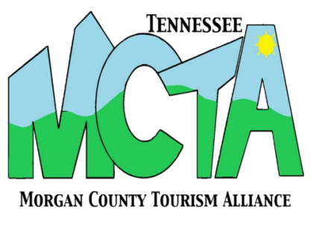
MOCO MUTTS PET PARADE
CONTEST RULES & ENTRY FORM

1. Registration will be conducted on site at the Northwest Corner of Kingston and Court Streets (across from Tanners Historic Cafe). A registration form is required for each pet you enter.
1. Animals must be up to date on their vaccinations (rabies)
3. Entry must not be obscene or offensive.
4. If any animal shows signs of aggression they must must leave event. Females in heat are prohibited.
5. No animal should be harmed from their costume or during the parade at any time.
6. Pets need to be on leash at all times and in control by their owner
7. Owners must clean up their pets waste
8. If children are walking their pet must be accompanied by an adult at all times.
9. Limit of two dogs per handler
10. Owners are liable and accountable for any injury or damage caused by their pet
11. MoCo Mutts or Morgan County Tourism Alliance reserves the right to disqualify any pet found in violation of the above rules and guidelines.
12. Registration fee is a donation to MoCo Mutts. Donations may be in cash or cans of cat food. Largest donation will get to lead the parade with Muttley!
13. Categories for prizes are Cutest, Best Costume, Best in Show

REGISTRATION INFORMATION

Owner’s Name __________________________________________ Phone: _____________________
Pet’s Name ____________________________________________ Pet’s Age ___________________ Breed_________________________________
Pet Dressed As: _____________________________________________________________________

Please Read Carefully and Sign:

I state that my animal(s) and I are in proper physical condition to participate in the MoCo Mutts Pet Parade and that my pet is up to date on vaccinations. I assume all risks associated with this event. I assume full responsibility for the control of my animal(s). I grant permission to MoCo Mutts and Morgan County Tourism Alliance to use any photographs, videos, or other recordings/reproductions of my animal(s) or myself for any promotional purpose without obligation or liability. Further, I hereby release and discharge MoCo Mutts, Morgan County Tourism Alliance, and any other participating agency(ies)
from any claims, liabilities, or cause of action I may have as a result of participating in this event, either foreseen or unforeseen.

Signature: ___________________________________________________ Date: __________________________

